Recommendations for community spirit event

This document consists of the recommendations that I have decided will help us in achieving our goals. However, most importantly it will give an indication of how I wish to generate the most amount of revenue possible for our selected charities, but with minimal expenditure involved.
Logo
My logo comprises of several things, one being the people cheering, the blue silhouettes which provides a vibrant effect which is simplistic yet effective, and my slogan in a stylish font and most importantly ‘community Spirit’ is written in a bold and eye catching format.
Strapline
Predicted ticket sales
Adult | 500
Children | 400
Income from ticket sales | £2,041
My Strapline is ‘Achieving together, Achieving more’ I have chosen this strapline because it shows that if the community work together they can achieve what they want and more.

Predicted sales
For our ‘community spirit’ event we have a projected ticket sale of 900 tickets (adults and children). From our predicted ticket sales we believe we will make an income of £1593.00. The tickets are priced at £2.49 per adult and £1.99 per child. We believe this is the right pricing strategy as it is not too much and it is also for charity so people will be prepared to pay this fee.

Venue
The chosen venue is the local Russell Park situated in the Bedford town centre. I have chosen this area because it is large enough to hold the predicted amount of people to come and all the pitches. Another benefit is that it is in the town centre so people who are in town to do their usual weekend shopping will be able to visit the event. There have also been previous events in this location that have been “Attracting people in excess of 300,000” which was for one of the previous events, the Bedford river festival.

Charities
I have chosen 4 charities for my event and am hoping to raise money for them. The chosen charities are: British Red Cross, cancer research U.K, St John ambulance, Muslim Aid. I have chosen these charities since they are local and a lot of people know about them and they have also helped a lot of people nationally and globally. Depending on the ‘Alternatives’

Smirnoff
Budweiser
Small coke Bottles

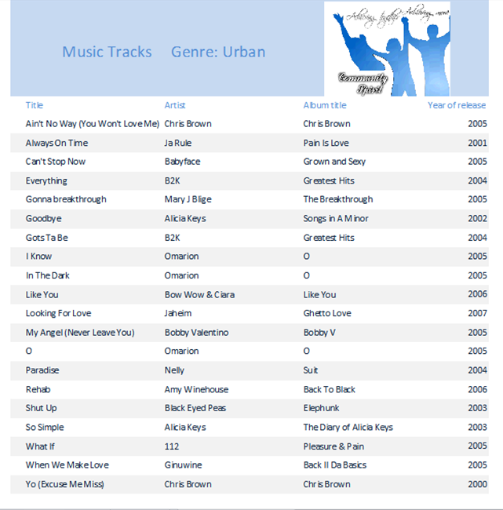
Shown above is my music track list which is from the decade of 2000 to 2010. All the music tracks are in the genre category of Urban as shown in the title.

Alternative 1
Activities | Cost
trampoline | £140.00
Attractions and activities
Name | Price | Predicted No. sold | Income
trampoline | £1.00 | 200 | £200.00
I have created a variety of alternatives such as if we rent out a trampoline for our event it will cost £140.00 to hire it. The predicted amount that we will make will cover the costs of hiring the Trampoline for the day so we will make a profit of £60.

Drink supplies
Tesco | £1,550.50
Asda | £1,580.00
Sainsbury's | £1,650.00
Waitrose | £1,700.00
Total | £1,650.00
For our drinks we have decided to buy them from Sainsbury’s because we know that they will deliver a high standard of drinks, despite costing more (chosen provider is highlighted in dark blue).

Hire of Pitches to charities
Number hired | 4
Income from pitch hired | £279.96
For this event we have decided to have 4 charities setting up pitches at our event.

Event overview
The predicted income for the whole event is £10,273.46 this is from all the ticket sales, food sales, drinks sales etc. the costs for the whole event is £5,002.50 and the overall profit is £5,270.96.

Alternative 2
Activities | Cost
bouncy castles | £280.00
Attractions and activities
Name | Price | Predicted No. sold | Income
Bouncy castles | £2.00 | 300 | £600.00
I have created a variety of alternatives for example if we rent out a Bouncy castle for our event it will cost £280.00 to hire it. The predicted amount that we will make will cover the costs of hiring the Bouncy Castle for the day so we will make a profit of £320.

Drink supplies
Tesco | £1,550.50
Asda | £1,580.00
Sainsbury's | £1,650.00
Waitrose | £1,700.00
Total | £1,550.00
For our drinks supplier I have chosen to buy them from Tesco because they are the cheapest option which will deliver a good quality but maybe not the best quality (chosen provider is highlighted in dark blue).

We have chosen to have 8 charities at our event because it will be a chance for small local charities to start to get more well-known and recognised. This is also another income as we will have £559.92 compared to having 4 charities which gives us £279.96 instead.
Hire of Pitches to charities
Number hired | 8
Income from pitch hired | £559.92

Event overview
The predicted income for the whole event is £11,446.45 this is from all the ticket sales, food sales, drinks sales etc. the costs for the whole event is £5,042.50 and the overall profit is £6,403.95.

Conclusion
I suggest that we use ‘Alternative 2’ because we will make more profit from it also if we rent the bouncy castle, despite it costing more for the event because I believe that the target audience for the bouncy castle is children. The targeted audience will be more attracted to it since many of them do not have it themselves while many children own a trampoline, so they will be less attracted if we have a trampoline so we will make more profit from the bouncy castle and more kids will enjoy it. If we chose Tesco’s over Sainsbury’s we will have a reduced cost of £100 which will result in a slight quality decrease.

Bibliography:
http://www.bedfordevents.co.uk/river-festival
Community Spirit spreadsheet.xlsx
..\Activity 1\MusicDatabase (1).mdb

